Papers written by Australian Maths Software

SEMESTER TWO

REVISION 3
MATHEMATICS METHODS
UNITS 3-4

2016

SOLUTIONS

SECTION ONE
1. (9 marks)
✓

(a) (i) After the first month.
(ii) 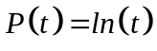
✓✓

(b) 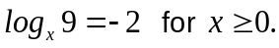
✓

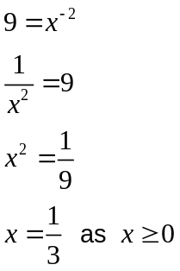
✓

✓

(c) 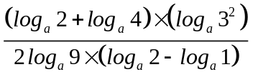
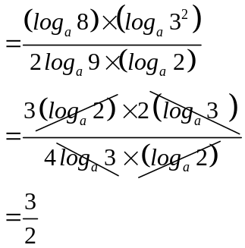
✓

✓

✓

2. (14 marks)
(a) (i) 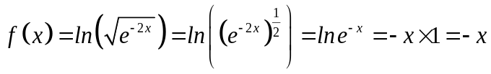
✓

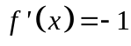
✓

(ii) 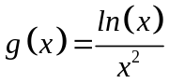
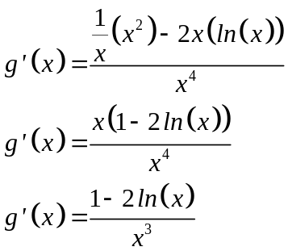
✓✓

✓

(iii) 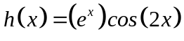
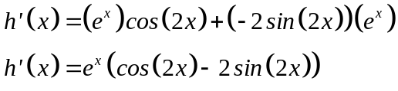
✓

✓

✓

(b) 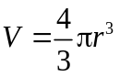
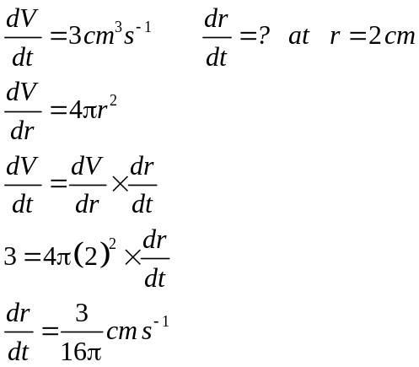
✓

✓

✓

(c) (i) 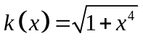 and 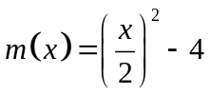
✓✓

(ii)
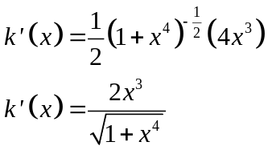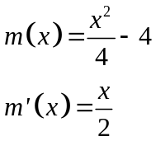
✓

✓

3. (7 marks)
(a) (i) (ii) (iii)
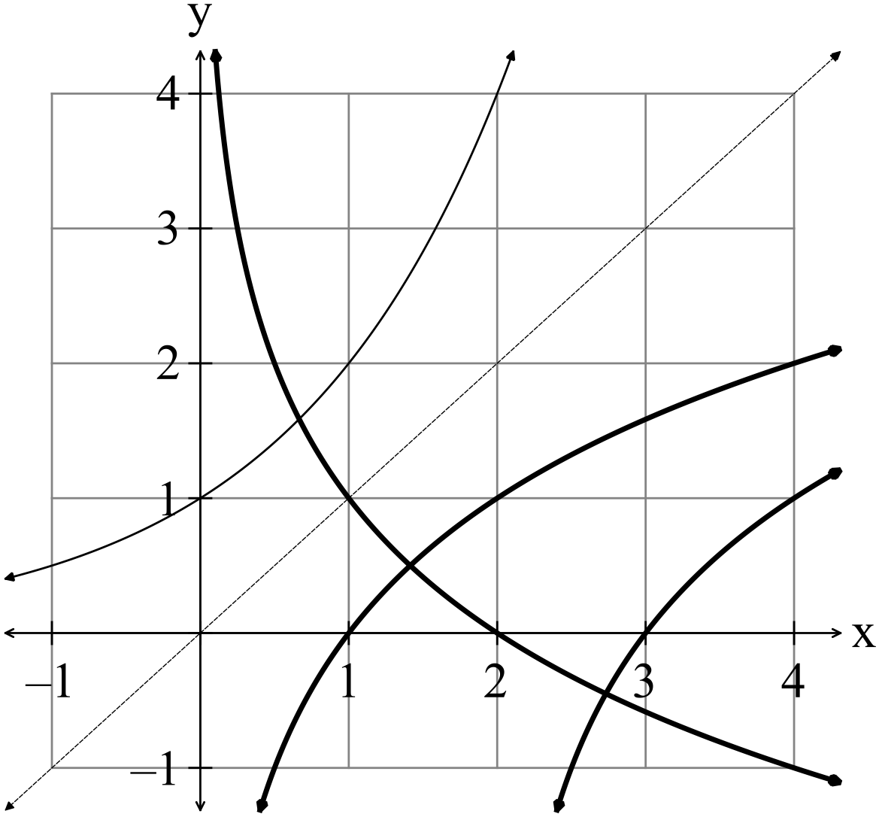
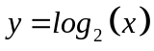
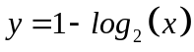
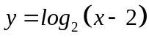
✓✓

✓✓

✓✓✓

4. (9 marks)
(a) (i) 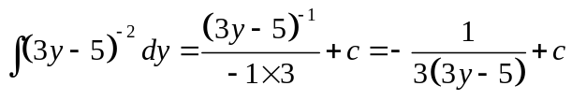
✓

✓

(ii)
✓

✓

(iii) 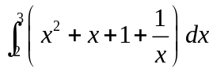
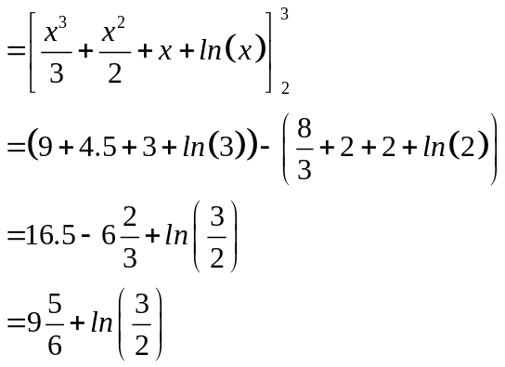
✓

✓

✓

(b) 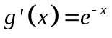
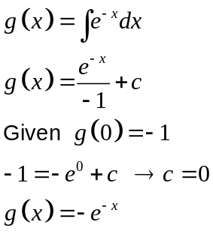
✓

✓

5. (11 marks)
(a)
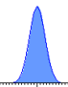
✓✓

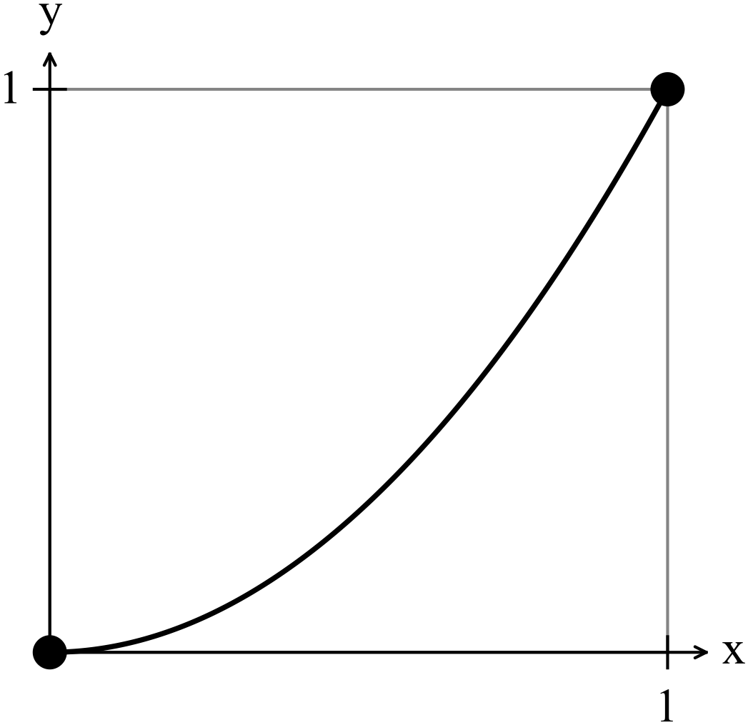(b) 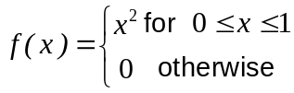
This function is NOT a continuous
probability density function as it is contained
inside a square of area one.

Therefore the area under the curve is less
than one.

Alternatively you can show that
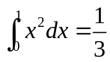
✓✓✓

(c) (i) Each sample has a mean which is the average of the sample. The average will
be closer to the population mean than independent samples as it will not include
outliers and be the average of the highs and lows.
Similarly, the mean of the means will be an even closer approximation to the
✓✓

population mean.

(ii) The means of the samples are closer to the population mean than the individual
scores. The mean of the means will be even more closely clustered. This means
✓✓

that the standard deviation of the sampling distribution will be very small.

(iii) Different types of bias when conducting a survey include
Selection bias (not a random sample)
✓✓ for any 3

Design flaw bias (no loaded questions)
Interviewer bias
Recall/reporting bias
Completion (lack of) bias
Non reponse bias (do not take part when selected)

END OF SECTION ONE
SECTION TWO
6. (4 marks)
(a) 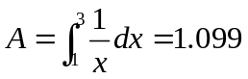
✓

✓

(b) Need the equation of the line.
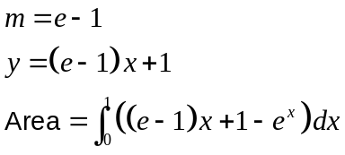
✓

✓

7. (10 marks)

(a) (i) 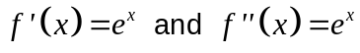
✓

(ii) There are no turning points on this graph, so 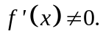
The functionis a continuous function which given 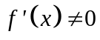 implies the
gradient of is either always positive or always negative.
It can be seen that the function is always increasing, so it is always positive.
The graph of 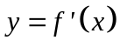is also always positive which confirms the gradient of
is either always positive.
The graph of 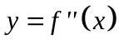is also always positive which means the concavity of
is constant and is concave upwards. There are no points of inflection which
require 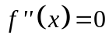.
So, with always positive we have an increasing function, together
with always positive, the function is concave upwards.
✓✓✓

(b) (i)
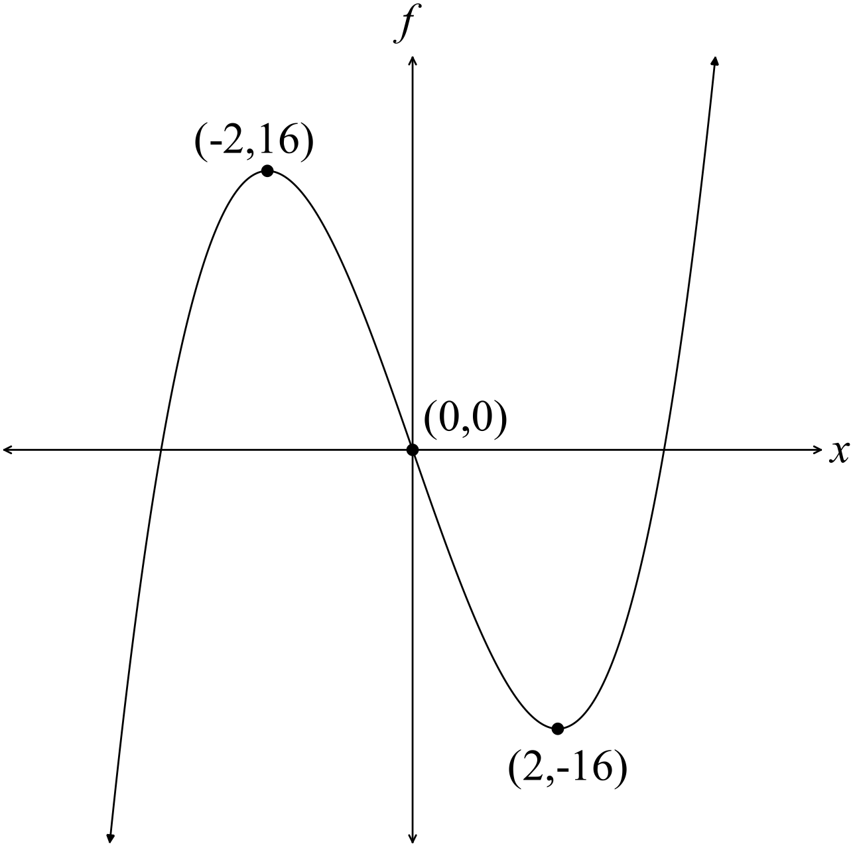
✓✓✓ -1/error

(ii)
✓
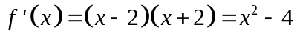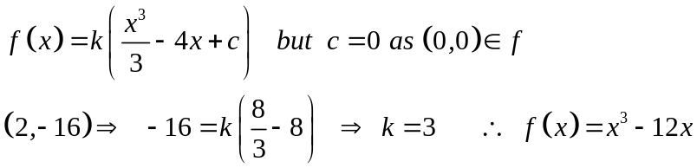
✓
✓
8. (6 marks)
(a) 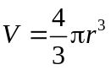
✓
✓
✓
✓
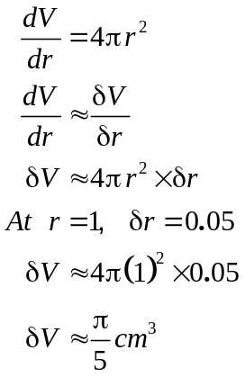
✓✓
(b) 1.38639 ( = ln(4) )
9. (5 marks)
(a) 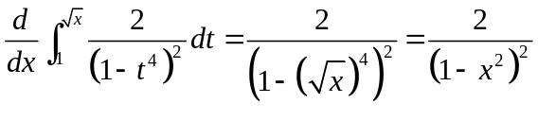
✓✓
✓

(b) (i) 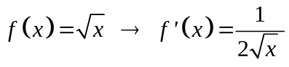
✓
(ii) 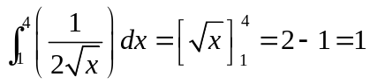
✓

10. (6 marks)
✓
(a) 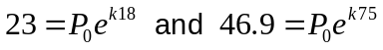
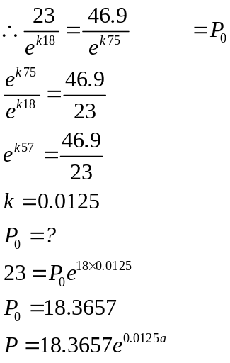
✓
✓
✓

(b) 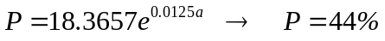
✓
✓

11. (6 marks)
(a) 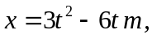
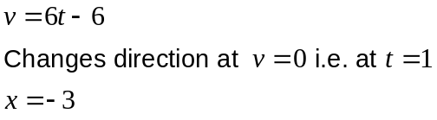
✓
✓

(b) 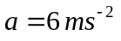
✓
240
✓
(c)
3
3
✓
✓

12. (8 marks)
(a) 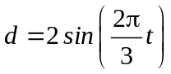
✓
(i) 2 cm up and 2 cm down so 4 cm.

(ii) Period = 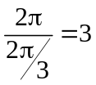 seconds

✓
(iii) 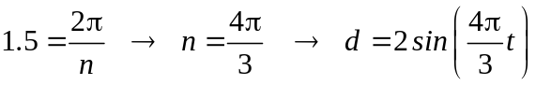
✓✓

(b) (i) 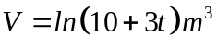
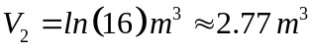
✓✓
✓
(ii) 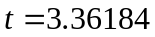
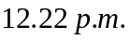
✓

13. (7 marks)
(a) 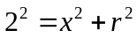
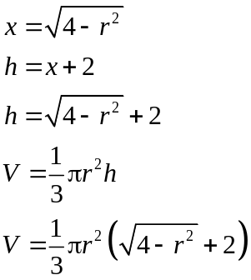
✓

✓

(b) To determine the dimensions of the cone of maximum volume:
✓

Find expressions for 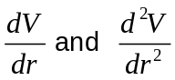 as maximum volume occurs when 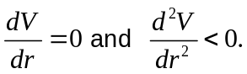
✓

Solve 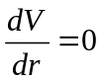 and exclude any values of that are negative or greater than 2.
✓

Test the solution for 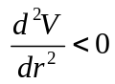 to ensure you have the maximum volume.
✓

✓

You need the dimensions of the maximum cone so calculate the value of .
Write a concluding statement giving the dimensions, h and r, that are required for the maximum volume of the cone.
-1 if mention of final statement.
14. (12 marks)
(a) (i)
Score when added | 2 | 3 | 4 | 5 | 6 | 7 | 8
P(score) | 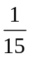 | 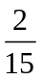 | 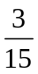
✓✓✓
(ii) P(the score is odd) = 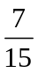
✓

(iii) P(there is at least one odd number) = 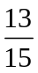
✓

(iv) P(a score of 6 or 7) = 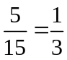
✓

(b) (i) 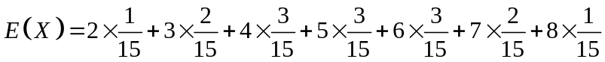 ✓
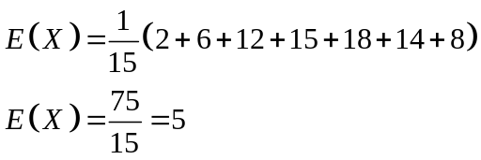
✓
(ii) 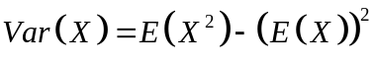
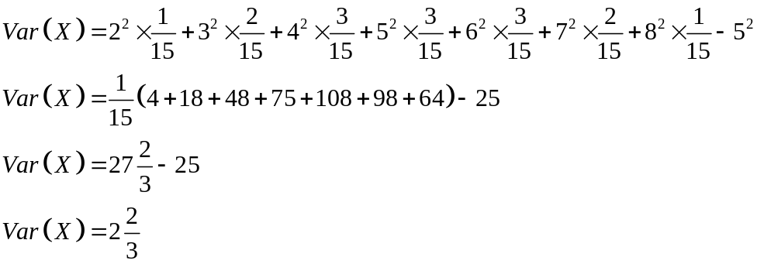
✓
✓

(c) (i) Not a probability density function as the probabilities do not add to 1. ✓

(ii) Not a probability density function as one of the probabilities is negative. ✓

15. (8 marks)

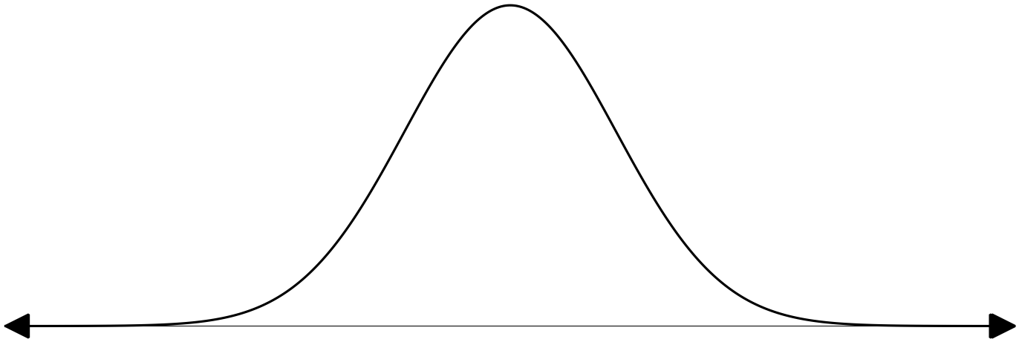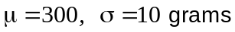
✓✓

(a) 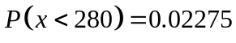
(b) 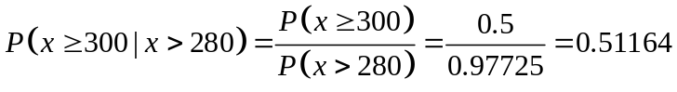
✓✓

✓

(c) B(4, 0,5)
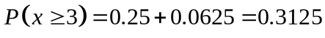
✓
✓
✓

16. (6 marks)
(a) 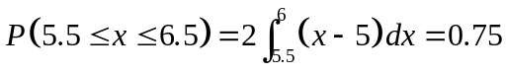
✓
✓
✓
(b) By symmetry, 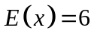
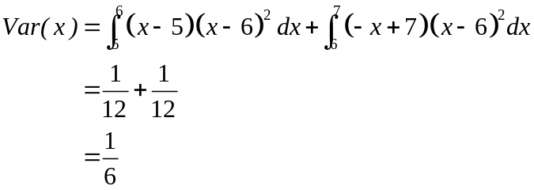
✓
✓
✓
17. (9 marks)
(a) P(on the next 6 Mondays Bill manages to buy a sultana bun) = 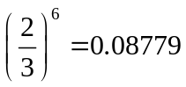
✓✓

(b) P(on the next 6 Mondays Bill only manages to buy a sultana bun 4 times out of 6) =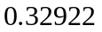
✓✓

(c) P(Bill can buy a sultana bun if on the last three Mondays the shop had run out of
buns. ) = 
✓✓

(d)
✓
✓

18. (14 marks)

(a)
✓
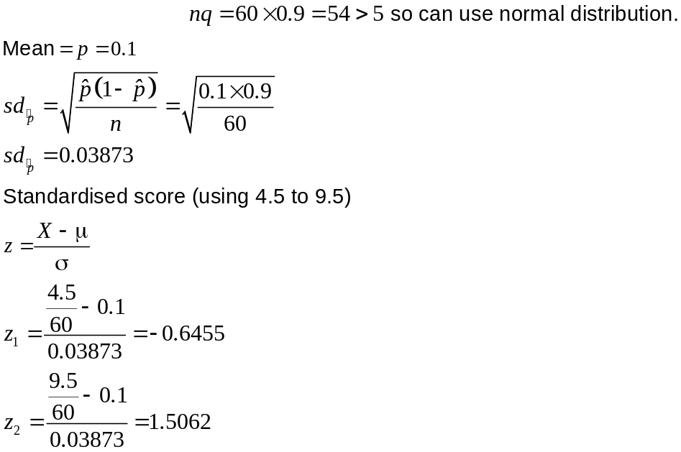
✓
✓
The probability is 0.675
✓
(b) (i) 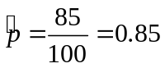
✓
(ii) 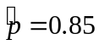
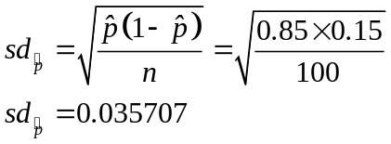
✓
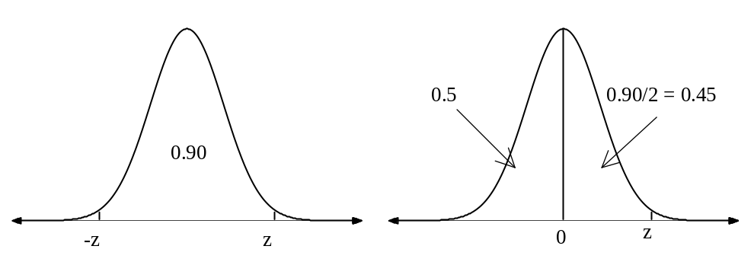
P(X< z) = 0.95
✓
z = 1.645
✓
s = 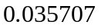
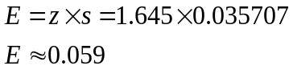
✓
✓
The confidence limit is 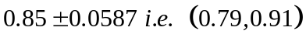
✓
(c)
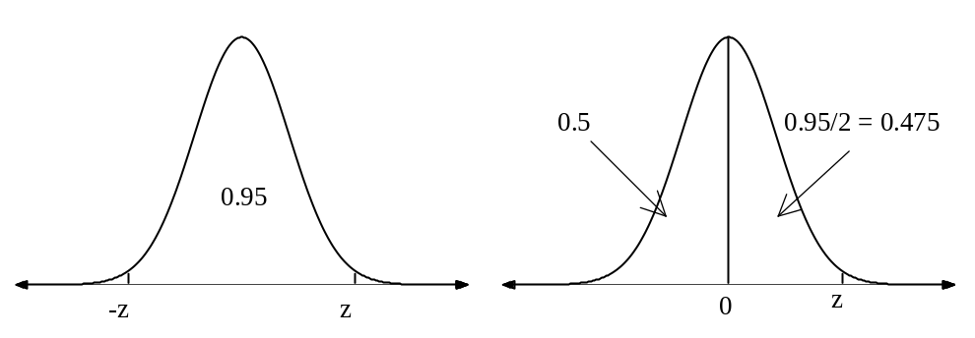
P(X< z) = 0.975
✓
So, 95% confidence level means z = 1.96
✓
Use 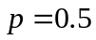 as the maximum value as is unknown.

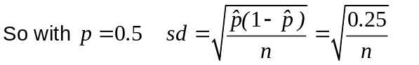
✓
E = z × s with 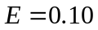

Therefore
✓
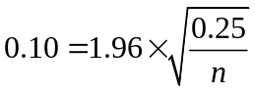
n = 96.04
✓

n ≈ 96

Should use a sample size of 96 people to have a confidence level of 95% with an
error margin of 10%

END OF SECTION TWO

